**Electric Start Kit**

BRP 850 ETEC – 2017+

**CAUTION** – Failure to follow these instructions could not only cause premature product failure.We recommend installation be done by a certified technician and/or someone with extensive knowledge of snowmobile electrical systems.

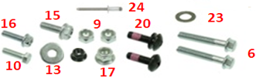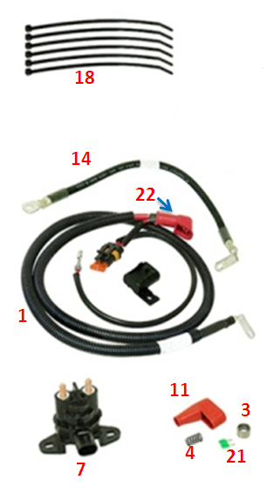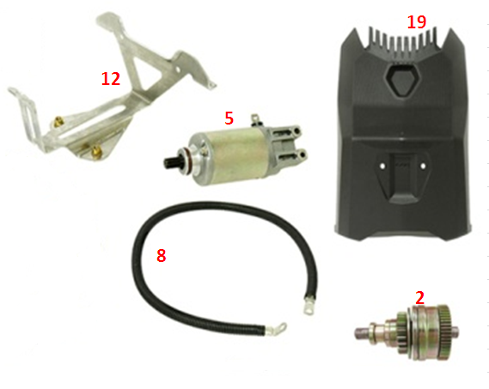**DISCLAIMER:** This item is sold without any expressed or implied warranty of merchantability or fitness for a particular purpose. By purchasing and installing this product the user agrees to these terms; the Manufacturer, Distributor nor Dealer shall be held liable for any special, incidental, or consequential damages, including vehicle damage, death or injury, any loss of revenue, any incurred cost, or cost of purchase from the use or misuse of this product.

|  |  |  |
| --- | --- | --- |
| **ITEM** | **DESCRIPTION** | **QTY** |
| 1 | Solenoid harness | 1 |
| Battery positive cable | 1 |
| 2 | Starter drive | 1 |
| 3 | Needle bearing | 1 |
| 4 | Spring | 1 |
| 5 | Starter Motor | 1 |
| 6 | M6 X 35 screw | 2 |
| 7 | Starter solenoid | 1 |
| 8 | Starter cable | 1 |
| 9 | M6 nut | 2 |
| 10 | M5 X 12 screw | 1 |
| 11 | Protective cap | 1 |
| 12 | Battery hold down bracket | 1 |

|  |  |  |
| --- | --- | --- |
| **ITEM** | **DESCRIPTION** | **QTY** |
| 13 | M5 washer | 1 |
| 14 | Battery negative cable | 1 |
| 15 | M6 X 16 screw | 1 |
| 16 | M5 X 10 hex flanged screw | 1 |
| 17 | M6 flanged nut | 1 |
| 18 | Locking tie | 6 |
| 19 | Battery cover | 1 |
| 20 | M6 X 20 screw | 2 |
| 21 | 30A fuse | 1 |
| 22 | Protective cap | 1 |
| 23 | Thrust washer | 1 |
| 24 | 3/16 Pop rivet | 1 |

**Notes**

* Battery not included- refer to OE information for proper application & service.

OEM BATTERY #415129898 (YTX20L-BS)

* Refer to appropriate service manual instructions for further detail throughout installation.
* Retain all removed components unless specifically noted.
* *Italic indicates provided parts.*

**Installation**

1. Using the shop manual, remove the following parts; upper body module, side panels, seat, drive pulley, muffler, exhaust pipe, rewind starter, crankshaft position sensor, MAG flywheel, and MAG housing screws.

***NOTE- Do not completely remove the MAG housing.

1. Refer to the shop manual for installation of *Starter Drive, Needle Bearing, Spring, Thrust washer, Starter Motor (*using item# 6 *M6 X 35 screws),* andCrankshaft position sensor. Torque *M6 X 35 screws* to 100 in. lb.
2. Refer to the shop manual for removal of the fuel tank.
3. Secure *Starter Solenoid* in the locking tabs under fuel tank.
4. Route *Starter Cable* from *Starter Solenoid* to *Starter Motor,* under air silencer on PTO side, along the bottom of engine compartment with a *locking tie* directly below PTO crankshaft end.
5. Install *Protective cap* on *Starter cable* and tighten to *Starter Motor* using item# 16 *M5 X 10 hex flanged screw.* Torque to 24 in. lb.
6. Located on the top of the tunnel, there is a clamp in the middle held in by a rivet. Remove the rivet, route the item# 1 *Battery positive cable* from *starter solenoid* under clamp, and reinstall using *3/16” Pop rivet.* Fix the *Battery positive cable* to tunnel using 2 *Locking ties* and the rear clamp.
7. Route *Solenoid harness* up and towards mag side along the other wire harness. Using 3 *Locking ties,* secure the fuse to the *battery positive cable*, and link to the other harness in 2 places.
8. Tighten the cables to the *starter solenoid* using 2 item# 9 *M6 nuts.* Torque to 35 in. lb. See illustration(A) on last page for proper mounting.
9. Locate the vehicle solenoid harness clipped into tunnel, next to the solenoid mount. Connect this harness to the *Starter solenoid*.
10. Apply Dielectric Grease to the *starter solenoid* connections and nuts.
11. Connect the terminal of *Solenoid harness* to cavity E in the fuse box. See the last page for illustration(B).
12. Install the *30A fuse* in fuse box.
13. Remove the protective film from the center of the tunnel.
14. Install the *Battery negative cable* to tunnel using item# 15 *M6 X 16 screw* & *item # 17 M6 flanged nut.* Torque to 89 in. lb
15. Using the shop manual, install the Fuel tank.
16. Place battery in the formed slot on Fuel tank.
17. Install *protective cap* on the *battery positive cable.*
18. Connect the positive, then negative cables to the battery. Torque to 89 in. lb.
19. Install *Battery hold down bracket* to Fuel tankusing item# 10 *M5 X 12 screw* & item# 13 *M5 washer.* Torque to 44 in. lb.
20. Install *Battery cover* using item# 20 *M6 X 20 screw*. Torque to 62 in. lb.
21. Test start vehicle using starter button.
22. Using the shop manual, install rewind starter, drive pulley, exhaust, upper body module, side panels, & seat.

